WORKS NOTICE – Parere Street Renewals
WHAT: | Site Investigation
LOCATION: | Parere Street |  | HOURS: | 7PM Onwards
DATE: | 17 December 2025 |  | TRAFFIC: | Stop Go
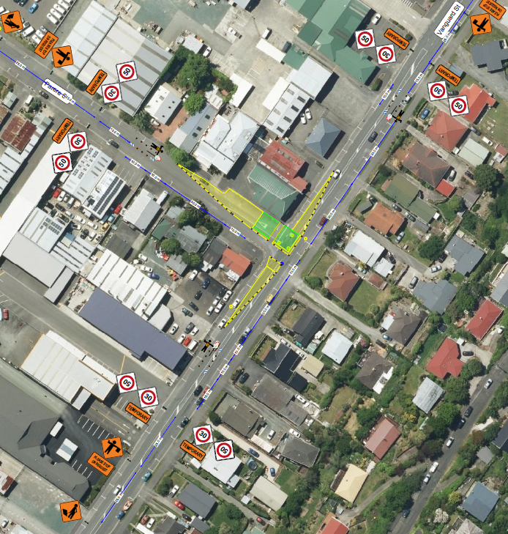
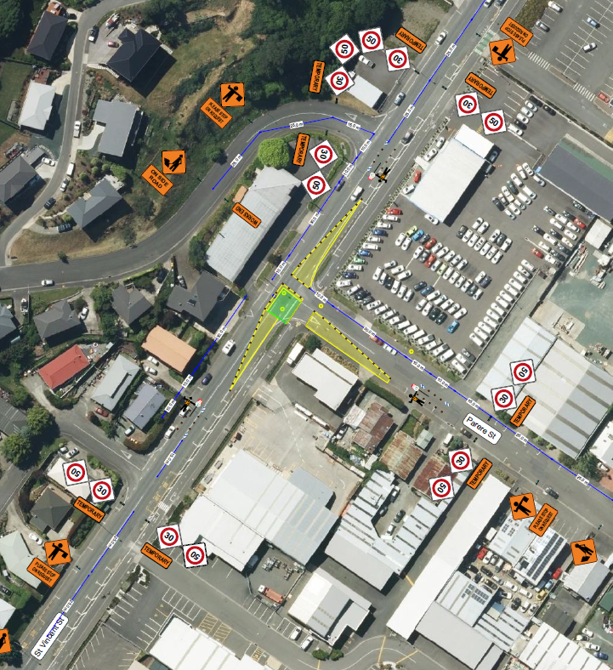
WHAT ARE WE DOING? |  | Further Investigation work will be carried out along Parere Street and at the intersections of Vanguard Street and St Vincent. This work will inform the wastewater upgrade. The road carriage will also be strengthened.
WHY ARE WE DOING IT? |  | The wastewater services in Parere Street are more than 70 years old and need to be replaced. Upgrading these services will help reduce future disruption for residents and businesses.
DURATION: |  | Investigation work should be completed within one night shift
MORE INFORMATION: |  | Traffic will operate under a Stop Go while works occurs (refer to the draft Traffic Management Plan above).  Bus services will be detoured during this time.  Please note this plan may be subject to change closer to the date.  Visit https://shape.nelson.govt.nz/parere-street-upgrades for more information.
CONTRACTOR INFORMATION: |  | Contractor: Schick Civil Construction  Contact: Lewis Wilson, 021801974

