
Council Project Manager: Claire McLean
Email: Claire.mclean@ncc.govt.nz
Phone: 03 546 0200
Infrastructure - Capital project
WORKS NOTICE – Arrow Street Retaining Wall
WHAT  WHEN |  | Retaining Wall Repair Works  Starting 19 May 2025 to Late July 2025
TRAFFIC |  | Road Closure – Arrow Street
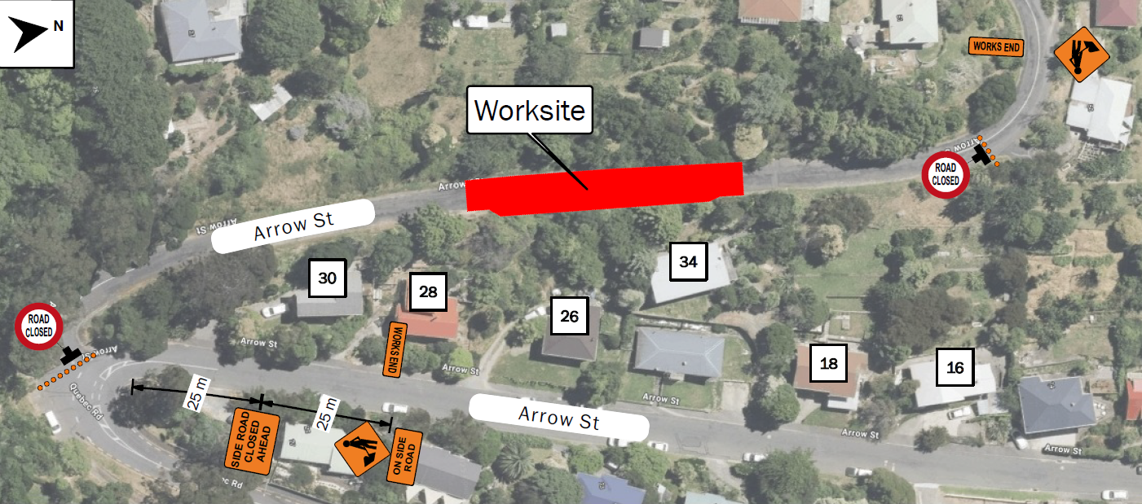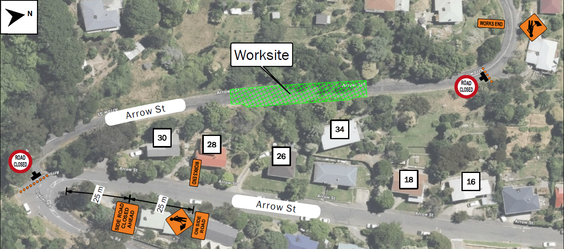

WHAT ARE WE DOING?
- Nelson City Council is repairing the retaining wall that supports the road carriage way as part of the recovery works programme.
- Hunter Civil have been engaged to carry out this repair. This will include drilling and ground anchor installation to stabilize the carriageway.

DURATION:
- Construction is scheduled to start on the 19 May 2025 and is estimated to be completed by Late July.
TRAFFIC CONDITIONS:
- Due to the narrow width of the road, a road closure is required while work is being carried out.
- Residents' access past site will be available outside of work hours (generally 7am to 5 30pm).
- Pedestrian and emergency access will be maintained at all times.
FIND OUT MORE:
- Visit Shape.Nelson.govt.nz for updates or email the Project Manager: Claire.mclean@ncc.govt.nz

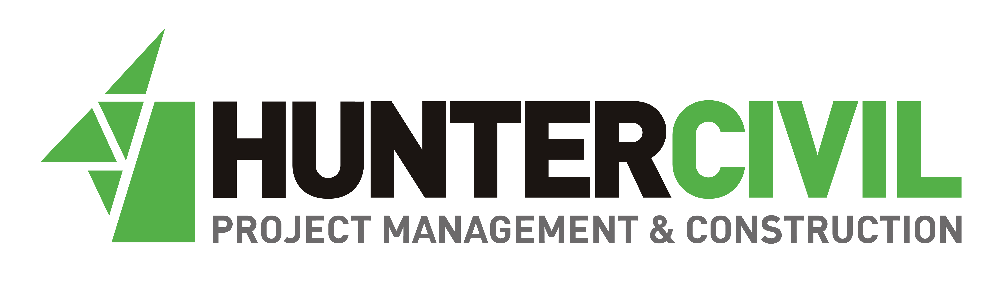

Hunter Civil 24-hour contact: 027 544 6632
Nelson City Council Contact: 03 546 0200

