Council Project Manager: Matt Christian
Email: Matt.Christian@ncc.govt.nz
Phone: (03) 539 5586

Infrastructure - Capital project
WORKS NOTICE – Street Safety Improvements
WHAT |  | Bay View Road – Pedestrian Refuge
WHEN |  | July 2023
TRAFFIC |  | Stop/Go Traffic Management
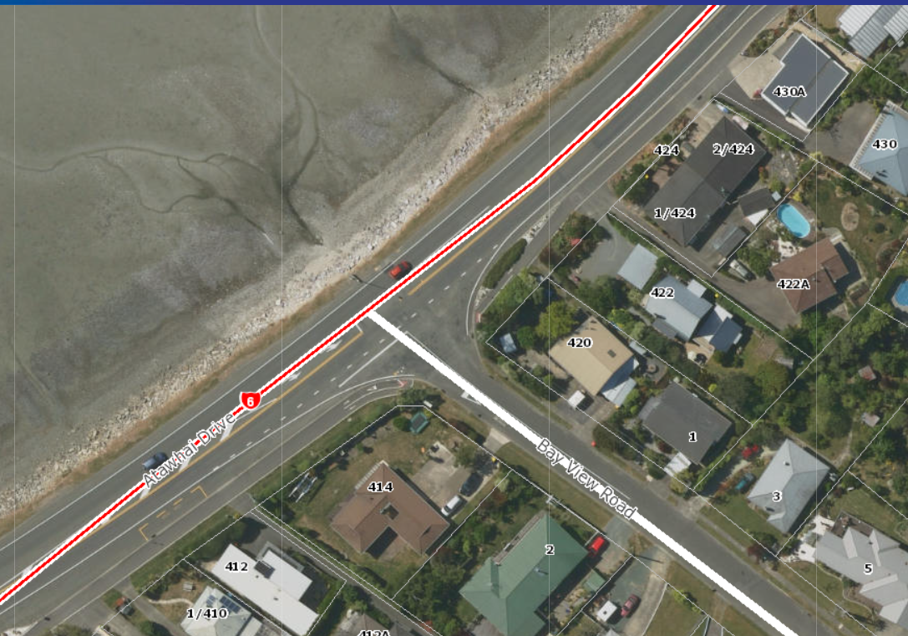

WHAT ARE WE DOING:
- We are installing a pedestrian refuge island at the crossing point across Bayview Road. This work involves narrowing the entrance to Bayview Road by building out the kerb and channel.
WHY ARE WE DOING IT:
- The purpose of these works is to improve the safety for all road users in this area. The pedestrian refuge will provide a safe place for cyclists and pedestrians whilst crossing the road in this busy area. The new kerb alignment will help slow traffic down as it enters and exits Bay View Road
DURATION:
- Work will begin in Mid-July and is expected to take around 3 weeks to complete (weather dependent).
TRAFFIC CONDITIONS:
- There will be Stop/Go traffic management in place for the duration of works, traffic will be released from Bay View Road by holding traffic on the State Highway. The Stop/Go traffic management will be in place between 9:00am-4:00pm daily.
FIND OUT MORE:
- Visit: https://shape.nelson.govt.nz/ or email Matt.Christian@ncc.govt.nz

Delivery Contractor: Isaac Construction Ltd
Site Contact: Jack Whittle, Ph: 027 938 5690 (24hr Contact)
Traffic Controller (STMS): Sean Wallis, Ph: 027 256 3608

Contractor Logo

