Ref: Atawhai Drive – Inbound Bus Stop
Civic House, 110 Trafalgar Street
PO Box 645, Nelson 7040, New Zealand

6 October 2026 | P (03) 546 0200
 | E road.enquiries@ncc.govt.nz
 | nelson.govt.nz
Dear Resident/Occupier

Proposed Road layout CHANGE – Atawhai Drive
Nelson City Council are proposing to relocate the existing inbound bus stop on Atawhai Drive, opposite Miyazu Japanese Garden. Due to the proximity to existing wastewater utility services the bus stop is proposed to be moved South of the current location. The change in location provides improved access for contractors and improved experience for waiting passengers.
We are seeking feedback from residents, occupants and eBus users. Details of the proposed changes can be found on the reverse of this letter.
Feedback on this proposed change needs to be received no later than 12:00pm Wednesday 21 October 2026. To provide feedback you can:
- Phone NCC Customer Service (03) 546 0200 – ref: Atawhai Drive – Inbound Bus Stop.
- Email road.enquiries@ncc.govt.nz with the subject: Atawhai Drive – Inbound Bus Stop.
- Visit shape.nelson.govt.nz, click on ‘Road and Parking Changes’ and fill in the online form.
All feedback received will be considered and used to inform a report that is presented to Elected Members at a Regulatory Process Panel Meeting scheduled for 9.00am Thursday 12 November 2026. There is a Public Forum available at this meeting if you wish to speak to your provided feedback. For more information, please visit the “Public Forum – speaking at meetings” page on All feedback received will be considered and used to inform a report that is presented to Elected Members at a Regulatory Process Panel Meeting scheduled for 9.00am Thursday 12 November 2026. There is a Public Forum available at this meeting if you wish to speak to your provided feedback. For more information, please visit the “Public Forum – speaking at meetings” page on our website – www.nelson.govt.nz
We look forward to hearing from you.
Nelson City Council

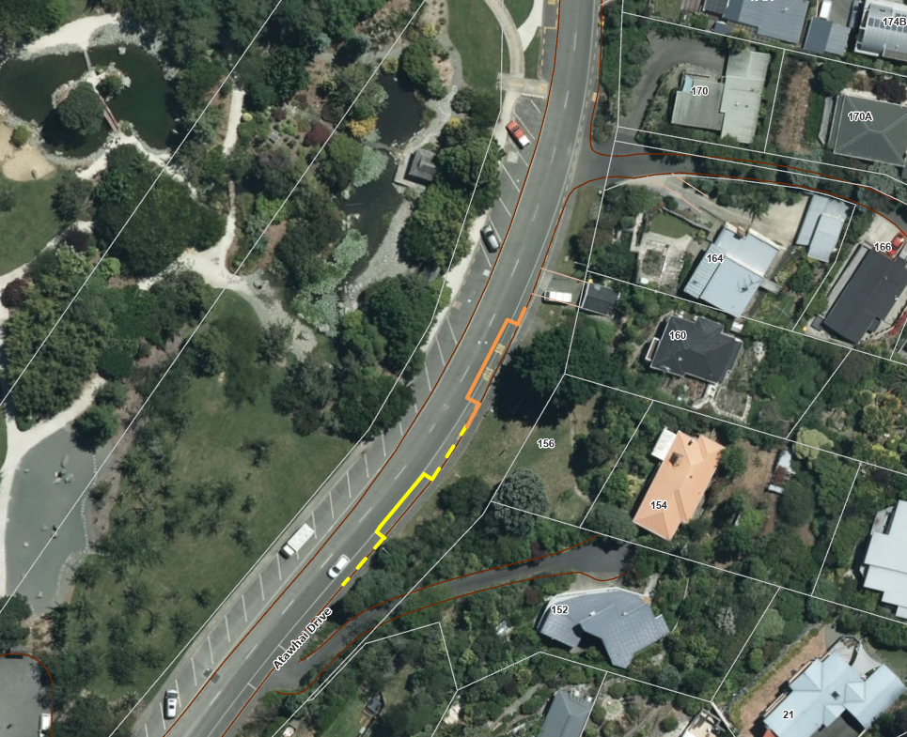
Proposed Inbound eBus Bus Stop Relocation on Atawhai Drive – yellow shows new proposed location, orange shows existing location.
Current location
Proposed new location

